26 de Noviembre de 2010

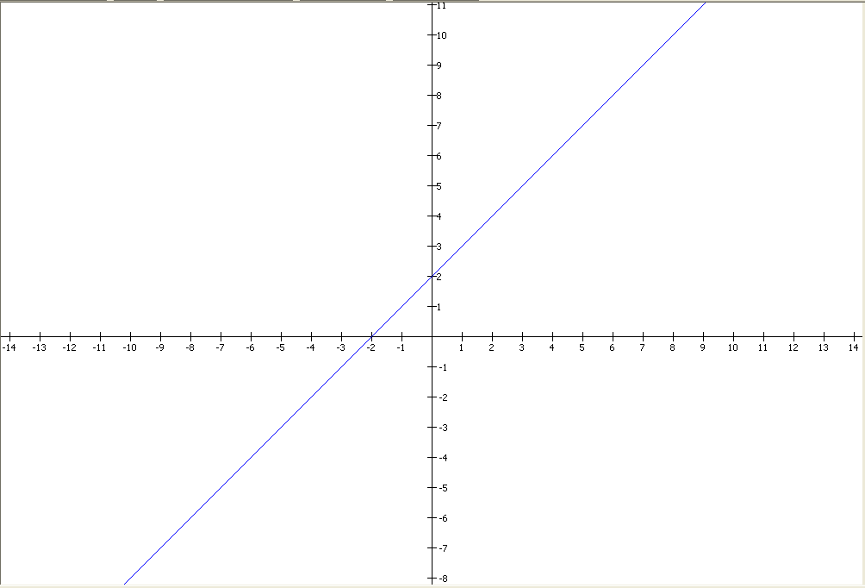

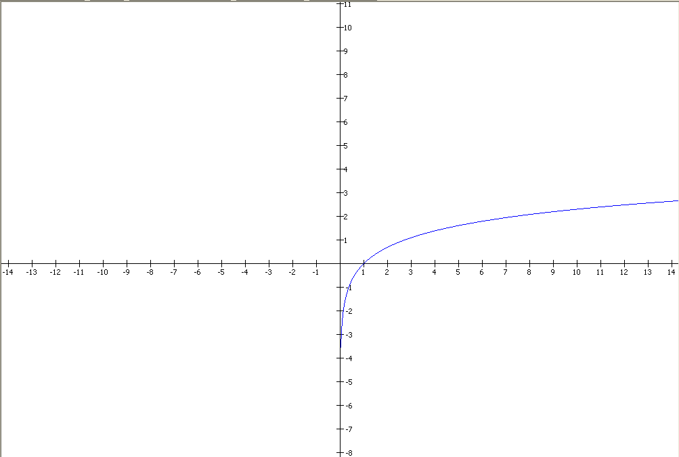

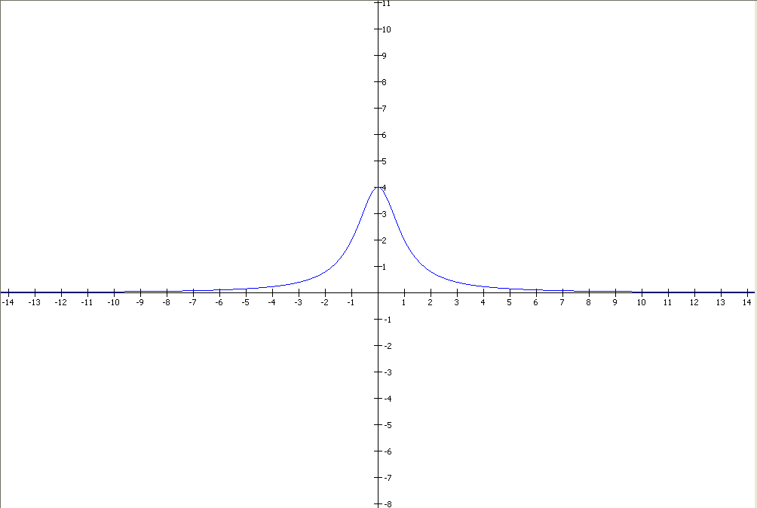

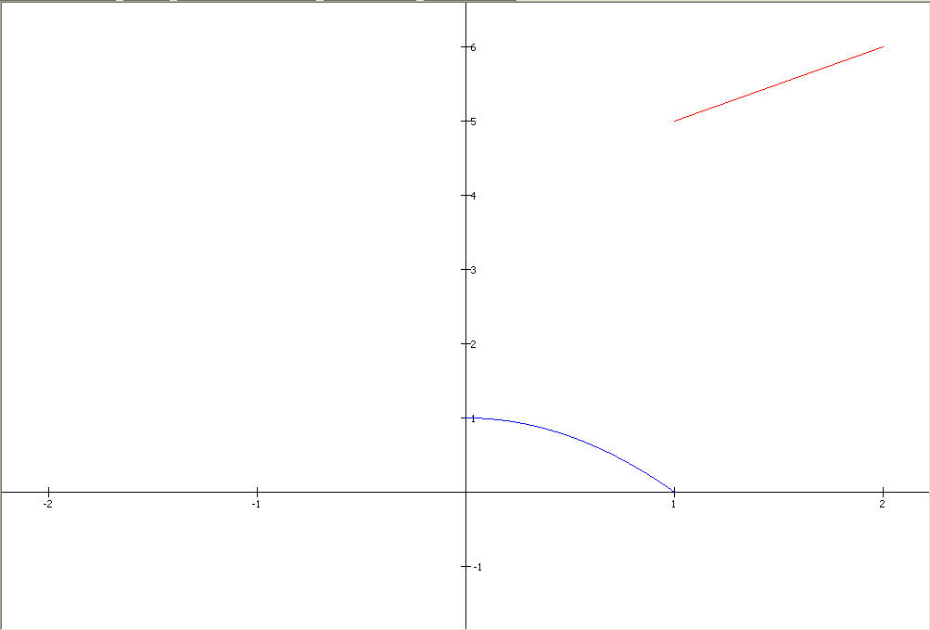

800 x 600 px

**Class Limites**

java.lang.Object

extended by java.awt.Component

extended by java.awt.Container

extended by java.awt.Panel

extended by java.applet.Applet

extended by javax.swing.JApplet

extended by **Limites**

**All Implemented Interfaces:**

java.awt.image.ImageObserver, java.awt.MenuContainer, java.io.Serializable, javax.accessibility.Accessible, javax.swing.RootPaneContainer

public class **Limites**

extends javax.swing.JApplet

**See Also:**

Serialized Form

|  |  |
| --- | --- |
| **Nested Class Summary** | |
| class | **Limites.Eventos** |

|  |
| --- |
| **Nested classes/interfaces inherited from class javax.swing.JApplet** |
| javax.swing.JApplet.AccessibleJApplet |

|  |
| --- |
| **Nested classes/interfaces inherited from class java.applet.Applet** |
| java.applet.Applet.AccessibleApplet |

|  |
| --- |
| **Nested classes/interfaces inherited from class java.awt.Panel** |
| java.awt.Panel.AccessibleAWTPanel |

|  |
| --- |
| **Nested classes/interfaces inherited from class java.awt.Container** |
| java.awt.Container.AccessibleAWTContainer |

|  |
| --- |
| **Nested classes/interfaces inherited from class java.awt.Component** |
| java.awt.Component.AccessibleAWTComponent, java.awt.Component.BaselineResizeBehavior, java.awt.Component.BltBufferStrategy, java.awt.Component.FlipBufferStrategy |

|  |
| --- |
| **Field Summary** |

|  |
| --- |
| **Fields inherited from class javax.swing.JApplet** |
| accessibleContext, rootPane, rootPaneCheckingEnabled |

|  |
| --- |
| **Fields inherited from class java.awt.Component** |
| BOTTOM_ALIGNMENT, CENTER_ALIGNMENT, LEFT_ALIGNMENT, RIGHT_ALIGNMENT, TOP_ALIGNMENT |

|  |
| --- |
| **Fields inherited from interface java.awt.image.ImageObserver** |
| ABORT, ALLBITS, ERROR, FRAMEBITS, HEIGHT, PROPERTIES, SOMEBITS, WIDTH |

|  |  |
| --- | --- |
| **Constructor Summary** | |
| **Limites**() |  |

|  |  |
| --- | --- |
| **Method Summary** | |
| void | **genera_valores**(double ini, double fin) |
| void | **init**() |
| void | **paint**(java.awt.Graphics g) |

|  |
| --- |
| **Methods inherited from class javax.swing.JApplet** |
| addImpl, createRootPane, getAccessibleContext, getContentPane, getGlassPane, getGraphics, getJMenuBar, getLayeredPane, getRootPane, getTransferHandler, isRootPaneCheckingEnabled, paramString, remove, repaint, setContentPane, setGlassPane, setJMenuBar, setLayeredPane, setLayout, setRootPane, setRootPaneCheckingEnabled, setTransferHandler, update |

|  |
| --- |
| **Methods inherited from class java.applet.Applet** |
| destroy, getAppletContext, getAppletInfo, getAudioClip, getAudioClip, getCodeBase, getDocumentBase, getImage, getImage, getLocale, getParameter, getParameterInfo, isActive, newAudioClip, play, play, resize, resize, setStub, showStatus, start, stop |

|  |
| --- |
| **Methods inherited from class java.awt.Panel** |
| addNotify |

|  |
| --- |
| **Methods inherited from class java.awt.Container** |
| add, add, add, add, add, addContainerListener, addPropertyChangeListener, addPropertyChangeListener, applyComponentOrientation, areFocusTraversalKeysSet, countComponents, deliverEvent, doLayout, findComponentAt, findComponentAt, getAlignmentX, getAlignmentY, getComponent, getComponentAt, getComponentAt, getComponentCount, getComponents, getComponentZOrder, getContainerListeners, getFocusTraversalKeys, getFocusTraversalPolicy, getInsets, getLayout, getListeners, getMaximumSize, getMinimumSize, getMousePosition, getPreferredSize, insets, invalidate, isAncestorOf, isFocusCycleRoot, isFocusCycleRoot, isFocusTraversalPolicyProvider, isFocusTraversalPolicySet, layout, list, list, locate, minimumSize, paintComponents, preferredSize, print, printComponents, processContainerEvent, processEvent, remove, removeAll, removeContainerListener, removeNotify, setComponentZOrder, setFocusCycleRoot, setFocusTraversalKeys, setFocusTraversalPolicy, setFocusTraversalPolicyProvider, setFont, transferFocusBackward, transferFocusDownCycle, validate, validateTree |

|  |
| --- |
| **Methods inherited from class java.awt.Component** |
| action, add, addComponentListener, addFocusListener, addHierarchyBoundsListener, addHierarchyListener, addInputMethodListener, addKeyListener, addMouseListener, addMouseMotionListener, addMouseWheelListener, bounds, checkImage, checkImage, coalesceEvents, contains, contains, createImage, createImage, createVolatileImage, createVolatileImage, disable, disableEvents, dispatchEvent, enable, enable, enableEvents, enableInputMethods, firePropertyChange, firePropertyChange, firePropertyChange, firePropertyChange, firePropertyChange, firePropertyChange, firePropertyChange, firePropertyChange, firePropertyChange, getBackground, getBaseline, getBaselineResizeBehavior, getBounds, getBounds, getColorModel, getComponentListeners, getComponentOrientation, getCursor, getDropTarget, getFocusCycleRootAncestor, getFocusListeners, getFocusTraversalKeysEnabled, getFont, getFontMetrics, getForeground, getGraphicsConfiguration, getHeight, getHierarchyBoundsListeners, getHierarchyListeners, getIgnoreRepaint, getInputContext, getInputMethodListeners, getInputMethodRequests, getKeyListeners, getLocation, getLocation, getLocationOnScreen, getMouseListeners, getMouseMotionListeners, getMousePosition, getMouseWheelListeners, getName, getParent, getPeer, getPropertyChangeListeners, getPropertyChangeListeners, getSize, getSize, getToolkit, getTreeLock, getWidth, getX, getY, gotFocus, handleEvent, hasFocus, hide, imageUpdate, inside, isBackgroundSet, isCursorSet, isDisplayable, isDoubleBuffered, isEnabled, isFocusable, isFocusOwner, isFocusTraversable, isFontSet, isForegroundSet, isLightweight, isMaximumSizeSet, isMinimumSizeSet, isOpaque, isPreferredSizeSet, isShowing, isValid, isVisible, keyDown, keyUp, list, list, list, location, lostFocus, mouseDown, mouseDrag, mouseEnter, mouseExit, mouseMove, mouseUp, move, nextFocus, paintAll, postEvent, prepareImage, prepareImage, printAll, processComponentEvent, processFocusEvent, processHierarchyBoundsEvent, processHierarchyEvent, processInputMethodEvent, processKeyEvent, processMouseEvent, processMouseMotionEvent, processMouseWheelEvent, remove, removeComponentListener, removeFocusListener, removeHierarchyBoundsListener, removeHierarchyListener, removeInputMethodListener, removeKeyListener, removeMouseListener, removeMouseMotionListener, removeMouseWheelListener, removePropertyChangeListener, removePropertyChangeListener, repaint, repaint, repaint, requestFocus, requestFocus, requestFocusInWindow, requestFocusInWindow, reshape, setBackground, setBounds, setBounds, setComponentOrientation, setCursor, setDropTarget, setEnabled, setFocusable, setFocusTraversalKeysEnabled, setForeground, setIgnoreRepaint, setLocale, setLocation, setLocation, setMaximumSize, setMinimumSize, setName, setPreferredSize, setSize, setSize, setVisible, show, show, size, toString, transferFocus, transferFocusUpCycle |

|  |
| --- |
| **Methods inherited from class java.lang.Object** |
| clone, equals, finalize, getClass, hashCode, notify, notifyAll, wait, wait, wait |

|  |
| --- |
| **Constructor Detail** |

**Limites**

public **Limites**()

|  |
| --- |
| **Method Detail** |

**init**

public void **init**()

**Overrides:**

init in class java.applet.Applet

**paint**

public void **paint**(java.awt.Graphics g)

**Overrides:**

paint in class java.awt.Container

**genera_valores**

public void **genera_valores**(double ini,

double fin)

Mayor información: https://github.com/derketzer/Estructura_Final